**DATA WAREHOSING WITH IBM CLOUD DB2 WAREHOUSE**

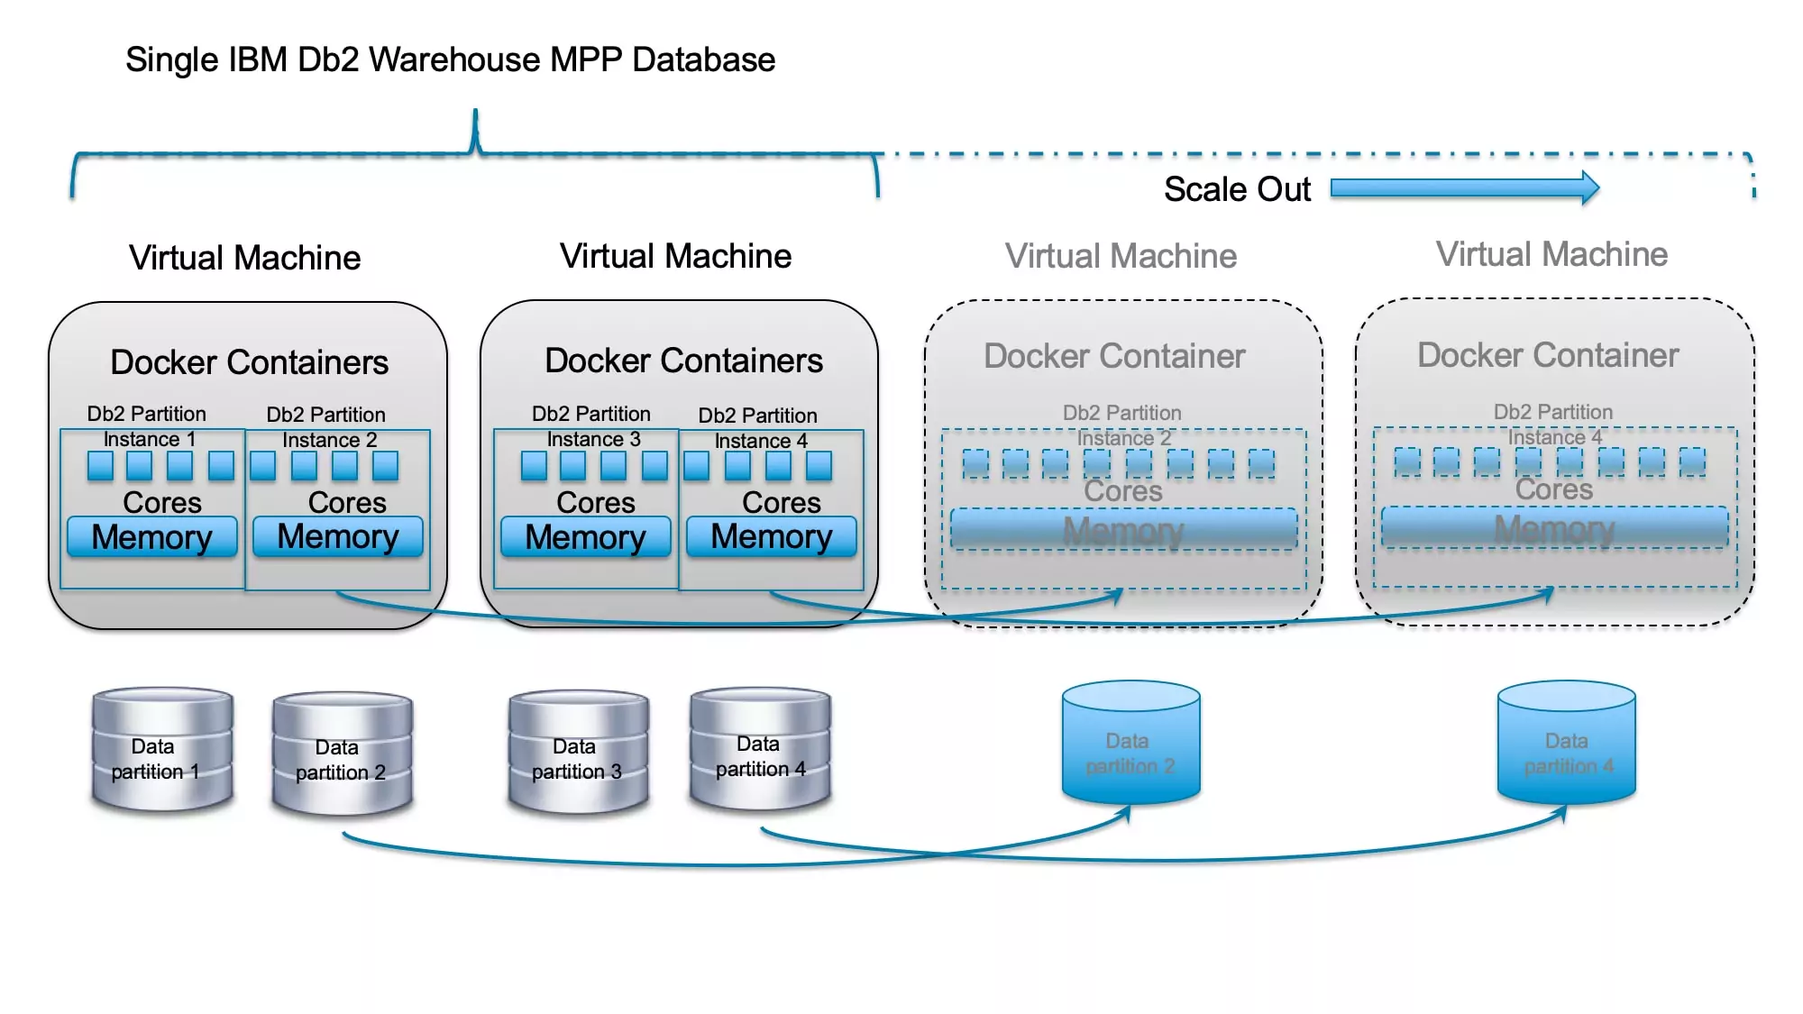

Machine learning (ML) models can be used for predictive analysis within the data warehouse to identify patterns and trends in historical data and use those insights to predict future outcomes. This can be used to improve decision-making in a variety of areas, such as sales, marketing, customer service, and fraud detection.

Regression Models:

* Linear Regression is Used for predicting a continuous numeric target variable based on one or more predictor variables.
* Logistic Regression is Useful for binary classification problems, such as customer churn prediction.

Decision tree:

* Decision trees are a simple but effective ML model that can be used for both classification and regression tasks. They work by splitting the data into smaller and smaller subsets based on the values of different features. The model then learns to predict the target variable based on the path that a data point takes through the tree.

Random forests :

* Random forests are an ensemble learning technique that combines multiple decision trees to produce more accurate and robust predictions. Random forests work by training each decision tree on a different subset of the data and then averaging the predictions of all of the trees.

Support Vector Machines (SVM):

* Useful for classification tasks and effective in high-dimensional spaces.

Neural Network

* Deep Learning models, such as Artificial Neural Networks, Convolutional Neural Networks (CNNs), and Recurrent Neural Networks (RNNs), can handle complex, non-linear relationships in data.

Clustering Algorithms:

* K-Means, DBSCAN, and hierarchical clustering are used for segmenting data into groups.

Time Series Models:

ARIMA (AutoRegressive Integrated Moving Average) and

* LSTM (Long Short-Term Memory) networks are used for time series forecasting.

Gradient Boosting:

* Algorithms like XGBoost, LightGBM, and CatBoost are popular for both regression and classification tasks due to their high predictive accuracy.

Natural Language Processing (NLP):

* For text data, models like TF-IDF, Word Embeddings, and deep learning-based models like BERT can be used for sentiment analysis, text classification, and more.

Recommendation Systems:

* Collaborative filtering and matrix factorization techniques are often used for building recommendation engines.

Anomly Detection

* Isolation Forest, One-Class SVM, and autoencoders are used to detect anomalies in data.

Time Series Analysis:

* Exponential smoothing, Prophet, and Seasonal Decomposition of Time Series (STL) can help inforecasting time series data.

Dimensionality Reduction:

* Principal Component Analysis (PCA) and t-Distributed Stochastic Neighbor Embedding (t-SNE) are used for reducing the dimensionality of data, which can improve model performance.

Concluision:

* When implementing these models within a data warehouse, it's essential to ensure that you have the necessary infrastructure and resources in place for data preprocessing, training, and model deployment. You'll also need to consider data quality, scalability, and integration with your existing data architecture.
* Additionally, tools like Apache Spark, TensorFlow, and scikit-learn are often used for implementing machine learning models within a data warehouse environment. Cloud-based services like AWS SageMaker, Google AI Platform, and Azure Machine Learning can simplify the process of building, training, and deploying machine learning models within a data warehouse

## *Thank you…*